Foundation for Virtual and Augmented Reality Systems
Prof. Samit Bhattacharya
Department of Computer Science and Engineering
Indian Institute of Technology, Guwahati
Week – 12
Lecture – 63
Concluding remarks
Hello and welcome to the last part of our concluding discussions. And with this part, we will be concluding our course, our discussion on the topics related to the course. So, welcome to this course on Foundations for Virtual and Augmented Reality Systems, and we are going to have the concluding remarks in this part of the course. Before we conclude, let us summarize what we have learned so far. Now, whatever topics we have covered in the earlier lectures, we can broadly divide them into six modules.
The first module was the introductory part, the introduction. Module 2 included discussion on the hardware and software that are used for extended reality systems. In module 3, we talked about human factors and the extended reality systems, what are the relevant factors and why they are relevant, and how to utilize that knowledge for building extended reality systems. Then actual system development concepts were taken up in module 4, building of XR systems.
Module 5 discussed optimization concerns, an important topic under this overall foundational aspect of extended reality, and we are concluding our discussion in module 6; that is, first we linked the theory to implementation, and then in today's lecture we are going to have the concluding remarks. Now, module 1, that is the introductory part, was spread over 12 lectures and weeks number 1, 2, and 3.
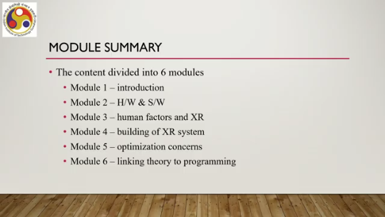
So, the introductory idea was introduced in what we talked about in lecture number 1 in the first week. Then we talked about the application domains and system categories. So, first was the introduction, then application domains and system categories in lecture number 2 and lecture number 3 again in week 1 of the lecture. We also talked about various definitions: the definition of AR, VR, presence, immersion, the definition of MR, how definition-wise AR and MR may not be separated, and so on, in lecture number 4 and 5, again in week 1.
Then we talked about the historical evolution of both AR and VR technologies. We covered it in lecture number 6. in week 1 and lecture number 7 in week 2. Issues and challenges were discussed, including a detailed discussion on the issue of cyber sickness. We devoted several lectures to it.
So, these were taken up; the discussion on issues and challenges was taken up in lectures number 8 to 11 in week 2 and lecture number 12 in week 3. So, week numbers 1 and 2 were fully devoted to the introductory part, and week number 3, the first lecture was also devoted to the introductory part. Let us talk about module 2. Now, there the topics were spread over 10 lectures covering weeks 3 to 5. So, we talked about the VR and AR hardware.
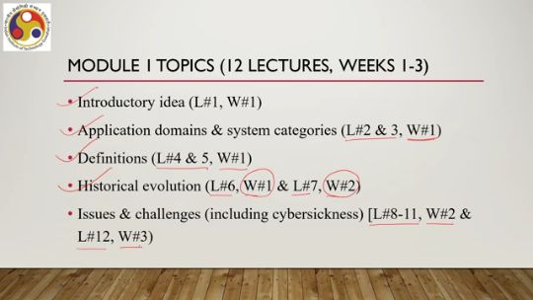
What are the hardware technologies, tools, and systems used to implement such systems? Essentially, this was a survey of such hardware. We covered those in lectures number 13 to 15 in week 3. We talked about tracking: the concept of tracking, the devices, the sensors, the methodologies, the basic understanding, all these things.
in lecture number 16 in week 3 and lectures number 17 and 18 in week 4. Now, the discussion included the concept, its importance in XR, why we need to know it, the hardware used, and the process of tracking. Also, we talked about VR and AR software again. It is a kind of overview of the software systems used for AR and VR. It was spread over lectures number 19 to 21 in week 4 and lecture number 22, which should be in week 5.
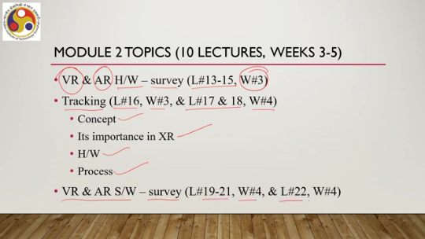
So, here, module 2 was spread between week 3 and week 5. It covers mostly weeks 3 and 4 and one lecture in week 5. Module 3 was spread over 9 lectures and 2 weeks. The idea of XR as an interactive system was the first topic we discussed. And why human factors are important considerations was also discussed under this topic.
And those discussions took place in lectures 23 to 26 in week 5. Then visual perception and display design. were covered under lecture number 27 in week 5 and lecture number 28 in week 6. Auditory sense and immersive experience were discussed in lectures 29 and 30 in week 6. Other senses and full immersion were discussed in lecture number 31 in week 6.
So, these are the topics related to module 3. primarily covering the human factors and their role in extended reality systems and experiences. Module 4 was a bit extensive and detailed. The topics were spread over 17 lectures, the largest, and spread over 4 weeks, weeks 6 to 10. The idea of the interactive system development lifecycle was discussed in lecture number 32 in week 6.
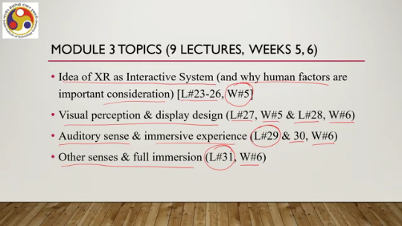
Then the Majuli case study was discussed in lectures 33 and 34 in week 7. We talked about the requirement gathering idea, particularly usability requirement gathering, in lectures 35 to 37 in week 7. We also talked about the system design aspects in lecture number 38, week 7, and lectures 39 to 41 in week 8. System implementation aspects were discussed in lecture number 42 in week 8, lectures 43 to 47 in week 9, and lecture number 48 in week 10. So, this module spanned 17 lectures and
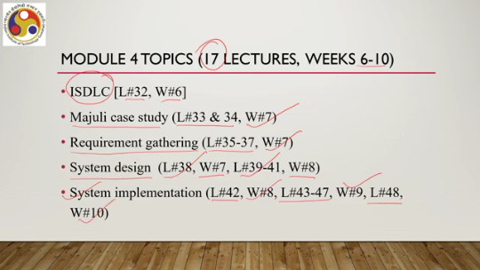
4 weeks. Module 5 talked about experience optimization. It was covered in 11 lectures and the span was between week number 10 to 12. So, we talked about VR experience optimization lectures number 49 to 52 week 10 and lecture number 53 week 11. which included discussion on how to do it in practice, that is relating the theory with a case study, the case study that we introduced earlier.
We also talked about their resource optimization concerns. The discussion was done in lecture number 54 to 56, week 11, and lecture number 57 to 59, week 12. Here also, we linked the discussion to practice through the case study, that is the Majuli Island Virtual Tour case study, how we implemented the resource optimization concerns, how we addressed the resource optimization concerns while implementing the case study. And the final module is module 6.
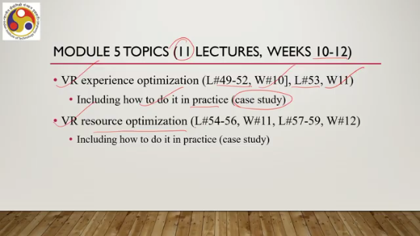
There are four lectures. This is the smallest, shortest module. All four were there in week 12. We have just finished discussion on programming support for developers, which is primarily how to link the theoretical knowledge to practice. And we had that discussion with respect to the Unity platform, spanning lecture number 60 to 62 in week 12.
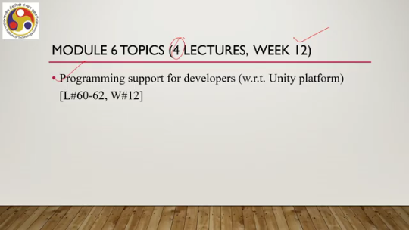
And then, these concluding remarks for lecture 63 in week 12 itself. Now we have covered many topics. Of course, many topics we have not covered also. If you recollect at the beginning, we mentioned that XR is interdisciplinary. That means it takes input from multiple disciplines.
Now we covered some of the most fundamental disciplines, but some other disciplines, some other topics of interest are left. What are those? Let us have a quick look. For example, we did not have any discussion on computer vision, but we all know that in AR or MR particularly, it has huge potential as an enabling technology for building better applications. Also, while talking about resource optimization, we mentioned how we utilized the concept of cloud support for
addressing the optimization concerns, but we did not have any discussion on cloud and edge computing concepts. But for scalable and affordable systems, these concepts are quite relevant. We also did not explicitly discuss machine learning or deep learning concepts. But as we all know, these are omnipresent concepts nowadays for building better experiences, having more intelligent systems which can provide better experiences. We did not cover LLMs or generative AI.
LLM stands for large language models, or generative AI. These can actually be utilized, and people are working on that, for enhanced interactivity. Even IoT, Internet of Things, and robotics are all relevant for these extended reality applications. Even blockchain technology is also relevant for such applications, but we have not covered these areas. And there are some more areas similar to these types of diverse technology areas or disciplines.
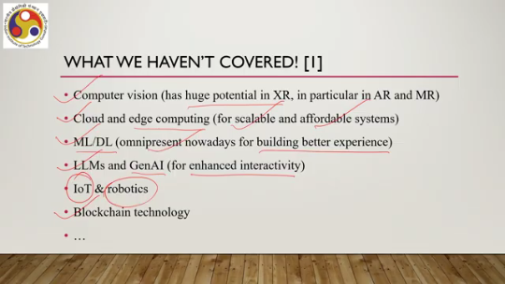
Our objective was to not to have mastery of each and every related discipline. That is not possible within the limited time period and limited scope. Instead, what we try to do is to build a foundation on which you can further build your skills or knowledge. So, essentially, we wanted this course to help you build a foundation on which you can extend your knowledge; you can build on top of that foundation.
I hope that the topics we have covered, which are curated topics, will be able to, or these topics will, or overall this course will help you achieve that objective; that is, you build a foundation, then for any other allied discipline that you need to know, you can extend your knowledge in that discipline based on the foundation that you get from this course. So, what are the relevant disciplines? What are the relevant technology areas from a technology or system development point of view?
I have mentioned a few areas, but for a better understanding of those areas and why they are relevant, you can go through this reference. It was published just last year and it quite exhaustively talks about relevant research areas and relevant disciplines, which are going to shape the future of extended reality applications. So, with that, I would like to conclude the lecture as well as the course. Just to repeat, the objective is to create a foundation rather than to master everything conceivable
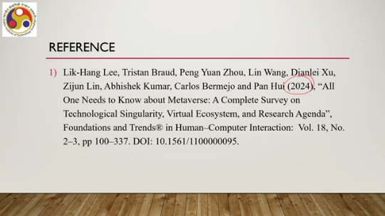
or associated with this discipline, and the foundational aspects we have covered, all the foundational aspects we have covered. I hope that you will be able to build the foundation by following the course material, following the lectures, and on top of that, you can extend your expertise, you can extend your knowledge as required when you actually start practicing in the field. So, I hope you enjoyed all the topics. You could follow the concepts we discussed.
And I hope overall you get the foundational idea of this discipline. With that, let us conclude. Thank you. Goodbye and happy learning.

